CELEBRITY GRIFFON OWNERS
VERNON & IRENE CASTLE

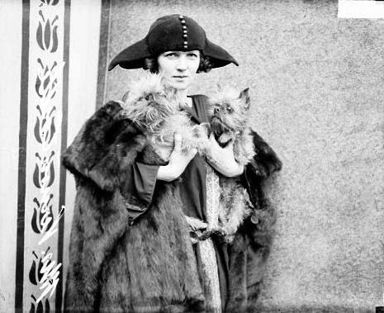

Irene with her Griffons in 1922

Vernon and Irene Castle were a husband-and-wife team of ballroom dancers of the early 20th century, who appeared on Broadway and in silent films. They are credited with reviving the popularity of modern dancing and led the craze for ragtime and Broadway routines adopted as social dances in the years before World War I.
Vernon was born in Norwich in 1887. Although he graduated from Birmingham University with a degree in engineering, he also worked as a magician in clubs and at private parties. He moved to New York with his sister and her husband, who were actors and Vernon soon turned to show business himself. In the early 1900s Castle appeared in a series of shows produced by Broadway comedian Lew Fields. Irene was born in 1893, in New York. Her grandfather was press agent for the Barnum and Bailey Circus. As a child she studied ballroom dancing. The couple reached the peak of their popularity in Irving Berlin's first Broadway show, Watch Your Step (1914), in which they refined and popularized the Foxtrot and Irene became a major fashion trendsetter.
Vernon sailed for England to enlist as a pilot in the Royal Flying Corps in 1916 and completed 300 combat missions before returning to the US to train American pilots. In 1918 was killed during a training exercise.
Irene starred solo in about a dozen silent films between 1917 and 1924 and appeared in several more stage productions before retiring from show business. She became an animal rights activist, married again, twice, and had two children. In 1939 a film - The Story of Vernon and Irene Castle – a Black-and-white movie based on the couples career was made - Irene, the aspiring dancer, was played by Ginger Rogers, convinces vaudevillian Vernon, played by Fred Astaire, to give up his comic act for something more serious: ballroom dancing!. Together, they work on perfecting their dance routine and take the act to Paris to become a sensation.

Many thanks to Pat Lee who drew my attention to the pictures of Irene in the first place!

